Budget Introduction

The main purpose of budgeting is to control thr expenditure. This is possible by creating budgets and comparing thr budged figures against the actual figures. You can generate report based onview the variances or difference between the actual and budgeted figures.  
Tally allows you to create multiple budget for specific purposes, for marketing

How to Activate Budget

Gateway of Tally->Masters->Create->Budget  
Gateway of Tally->Masters->Create->Click Show More->Budget

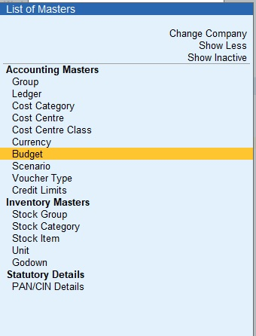

Create Budgets for Groups

On enabling budgets , the option to create Budgets is available in the Show more Option. You can create budgets for groups like expenses, sundry debtors, sundry creditors, and more. By doing so, the budget defined will be applicable for all ledgers classified under this group,  
  
1.Gateway of Tally->Masters->Create->Budget  
2.In the Budget Creation screen, enter a name for your budget.  
3.In the Under field, select the required budget from the List of Budgets . By default, Primary is selected from the List of Budgets  
4.Sub-budgets can be created under primary budgets  
5.Enter the period of the budget in the From Date and To Date fields.  
6.In Set/Alter Budgets of , enter Yes in the Groups field.

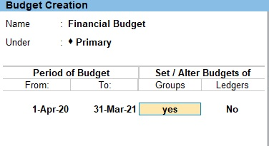

1.Select the required Type of Budget  
2.Enter the budget amount in the Amount field  
3.Press Enter

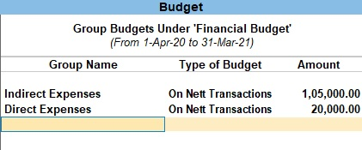

Create Budgets for Ledgers

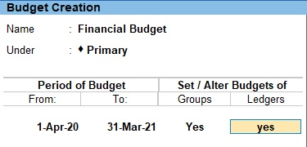

1.In Set/Alter Budgets of , enter Yes in the Groups field  
2.Select the required Type of Ledger  
3.Enter the budget amount in the Amount field  
4..Press Enter

**Note:**  
**On Nett Transactions:** On Nett Transactions to monitor the transaction amounts and not the balances. Nett is net of debits and credits for the specified period.  
**On Closing Balance:** On Closing Balance to monitor the balances of the Accounts and the not the transactions. i.e., each month will have the same budget value except that the actual Opening Balance is also taken into account

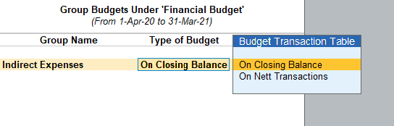

Budget Sum

The Following Would Be Recording In Journal Using Double Entry System. Do The Posting Process From Journal Entries And Prepare The Trial Balance, Trading A/C, Profit & Loss A/C And Balance Sheet In The Books Of M/S. INFOTECH LTD For The Following Year 2020 to 2021

|  |  |
| --- | --- |
| Capital | 5,00,000 |
| Cash | 2,50,000 |
| Bank Loan | 1,00,000 |
| Profit & Loss A/C | 50,000 |
| Accounts Receivable | 50000 |
| Axis Bank | 1,50,000 |
| Machinery | 75,000 |
| Plant & Machinery | 1,50,000 |
| Good Will | 75,000 |
|  |  |
| Bank O /D | 1,00,000 |

**Title of the Budget:**Financial Budget  
**Period of Budget:**1.4.2020 to 31.3.2021

|  |  |
| --- | --- |
| **Ledger Name** | **Estimated Amount**(Rs) |
| Stationery | 10000 |
| Rent | 50000 |
| Salary | 20000 |
| Wages | 15000 |
| Fright Charges | 5000 |
| Discount | 5000 |
| Commission | 10000 |
| Depreciation | 10000 |
|  |  |

Transaction During The Period

1. Paid Telephone Charges Rs.2000  
2. Goods Purchased On Credit From M/S.Linga Agencies Was Rs.100000  
3. Paid Salary By Cheque Rs.10000  
4. Provision For Depreciation Rs.15000 Allocate In To P&L A/C  
5. Paid For Rent: 20000, Stationery: 4000, Wages: 6000  
6. Paid Fright Charges Rs.3750 By Cheque  
7. Paid To M/S.Linga Agencies And Discount Received @ 5%  
8. Paid For Salary: 10000, Rent: 30000, Stationery: 1750  
9. Received Interest amount Rs.25000  
10. Discount Allowed Rs.3000